Twitter Thematic Classification Using Transformer/BERT – Advanced Machine Learning Project

Applicant: Ibrahim Akintunde Akinyera
Criterion: Optional – Proven Technical Expertise
Source: MSc Dissertation
Supporting Files:
- FINAL RWM-IBR-PROJECT.docx
- slides_Text_analysis_marketing.pptx

1. Executive Summary

This evidence demonstrates my advanced technical expertise through the development of a deep learning, transformer-based text classification system that analyses and categorises Twitter data into three themes: Sports, Entertainment, and Politics. This was a fully independent project carried out during my MSc Data Science programme and includes data engineering, NLP preprocessing, BERT embeddings, GPU-accelerated training, model optimisation, and evaluation metrics.

The system achieved a high performance score with an F1 score of 0.96, demonstrating state-of-the-art classification accuracy. This evidence directly meets the Global Talent requirement for proven technical expertise in building complex AI/ML solutions.

2. Technical Problem & Project Objective

Brands, marketers, and analysts often classify social media content manually. This process is slow, inconsistent, and not scalable. My objective was to develop an automated machine learning pipeline that:
- Extracts tweets using Twitter API + Tweepy
- Cleans and preprocesses noisy text data
- Generates vector representations using BERT contextual embeddings
- Trains a transformer-based classifier using TensorFlow
- Evaluates performance using confusion matrices, F1 scores, and loss curves

As described in my dissertation:

“This research aims to develop machine learning algorithms that can reduce the laborious effect of manually assigning themes to text content…”

3. My Technical Contributions

A. Data Extraction Pipeline (Python + Tweepy)

I developed a custom Python script (crawler.py) to extract:
- 10,000 tweets per category (Sports/Entertainment/Politics)
- Original tweets only (retweets removed)
- Full, extended text (not truncated)

This is confirmed in the dissertation:
“Ten thousand samples (tweets) from each class were extracted… retweeted tweets are excluded…”

B. Exploratory Data Analysis (NLP Visualisation)

I conducted POS tagging, unigram/bigram/trigram extraction, and produced word clouds for each category:
- Figure 3 – Entertainment nouns
- Figure 4 – Politics nouns
- Figure 5 – Sports nouns

These were used to identify lexical patterns relevant to classification.

C. Data Preparation & NLP Preprocessing

Implemented:
- Emoji/URL/@-tag removal
- Tokenisation
- Stopword removal
- Stemming & Lemmatization
- Padding and masking for sequence inputs

“Twitter data contains elements that need to be removed… symbols, emojis…
Stemming and lemmatization performed…
Inputs padded to max length of 512 tokens.”

D. BERT Embedding & Transformer Architecture

I used BERT uncased base embeddings (768-dimension vectors):

“BERT embedding was used as the feature extractor-representing each token in 768 vector dimensions…”

Architecture included:
- BERT embedding layer
- Dense classification layer (3-class softmax)
- Dropout regularisation:
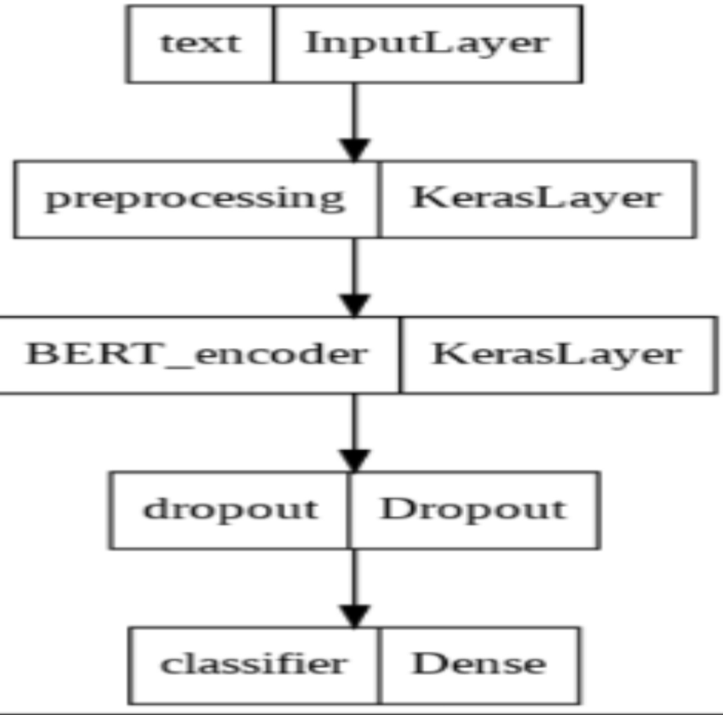
Figure 8 – Model Architecture

E. Model Training & Optimisation
- Trained on GPU
- Dataset split into training/validation/test
- Used Adam optimizer & Learning Rate Scheduler
- Implemented EarlyStopping to prevent overfitting

From dissertation:

“Early stopping was used… checkpoints saved best model…
Model trained with 7000 samples per class.”

F. Evaluation & Metrics

Results include:
- Training/validation accuracy curves
- Confusion matrix
- Classification report
- Macro F1 score: 0.96

All shown in your dissertation:
- Figure 9 – Performance Curve
- Figure 10 – Classification Report
- Figure 11 – Confusion Matrix

4. Results & Impact

The model achieved:
- 96% accuracy
- Strong performance across all three categories
- Robust semantic understanding due to BERT

From dissertation:

“The model shows excellent performance… f1 score of 96% on the test set.”

This system can be adapted for:
- Social listening
- Marketing segmentation
- Crisis detection
- Automated content moderation
- Trend analysis

This demonstrates advanced ability to design and build scalable AI and NLP systems.

5. APPENDIX (Screenshots to Insert in Word Document)

Paste these screenshots exactly in this order:

Appendix A – Title Page of Dissertation

📎 Screenshot of page 1 (Title + author details)

Appendix B – Flowchart (Model Development Stages)
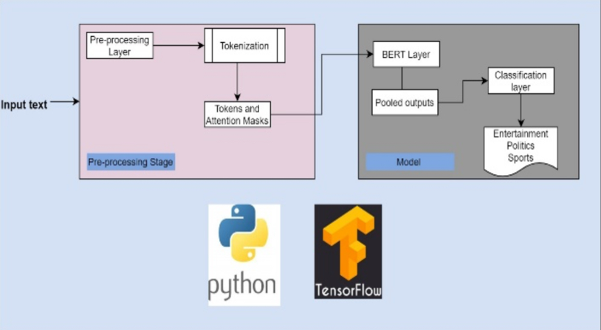
Figure 1.
“Flowchart showing stages of model development”

Appendix C – NLP Visualisations
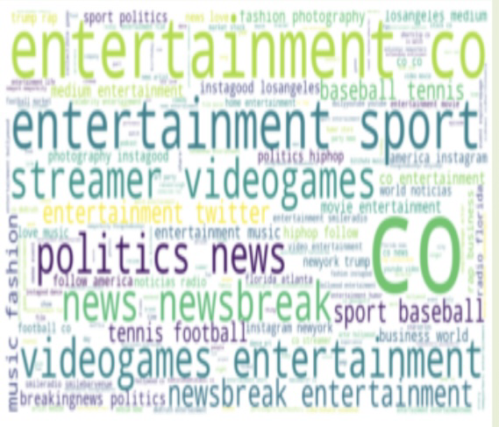
Figure 3 – Entertainment Word Cloud

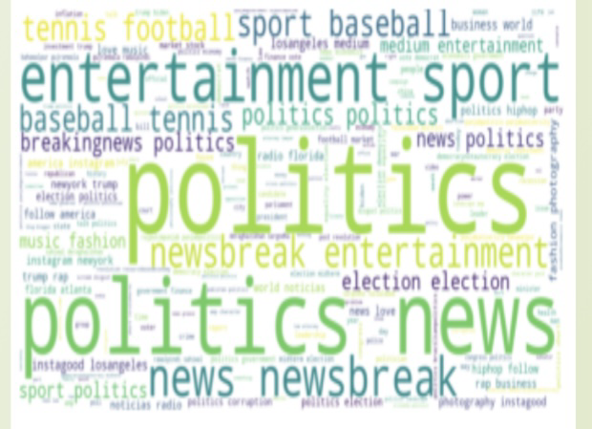
Figure 4 – Politics Word Cloud
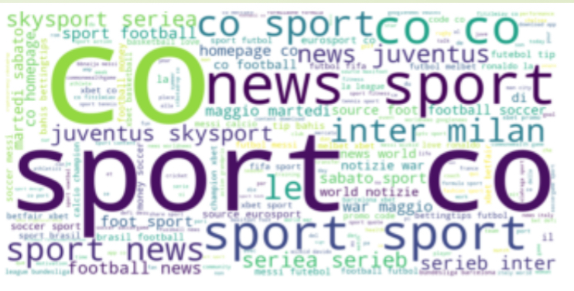
Figure 5 – Sports Word Cloud

Appendix D – Model Architecture

📎 Figure 8 – Transformer Architecture Diagram

Appendix E – Model Performance Screenshots

📎 Figure 9 – Training/Validation Curves
📎 Figure 10 – Classification Report
📎 Figure 11 – Confusion Matrix

Appendix F – Code Extracts

bert_layer = hub.KerasLayer(
"https://tfhub.dev/google/bert_uncased_L-12_H-768_A-12/1",
trainable=False
)
model = tf.keras.Sequential([
bert_layer,
tf.keras.layers.Dropout(0.2),
tf.keras.layers.Dense(3, activation='softmax')
])

